**Clarion Rec Center Management Program Implementation Manual**

This manual will describe the process of implementing the Clarion Rec Center Management Program.

Proper installation of the Clarion Rec Center Management Program requires a computer running Windows, and the installation file. The installation file will be located on the Clarion Rec Center shared folder. Computing Services will have to authorize any installations on any Clarion University computer.

**Installation:**

- To install the program on a new computer, make sure the computer is connected to the Clarion Rec Center network.

- Open the shared folder and select the installation file

- Open the installation file and simply run the “setup” file.

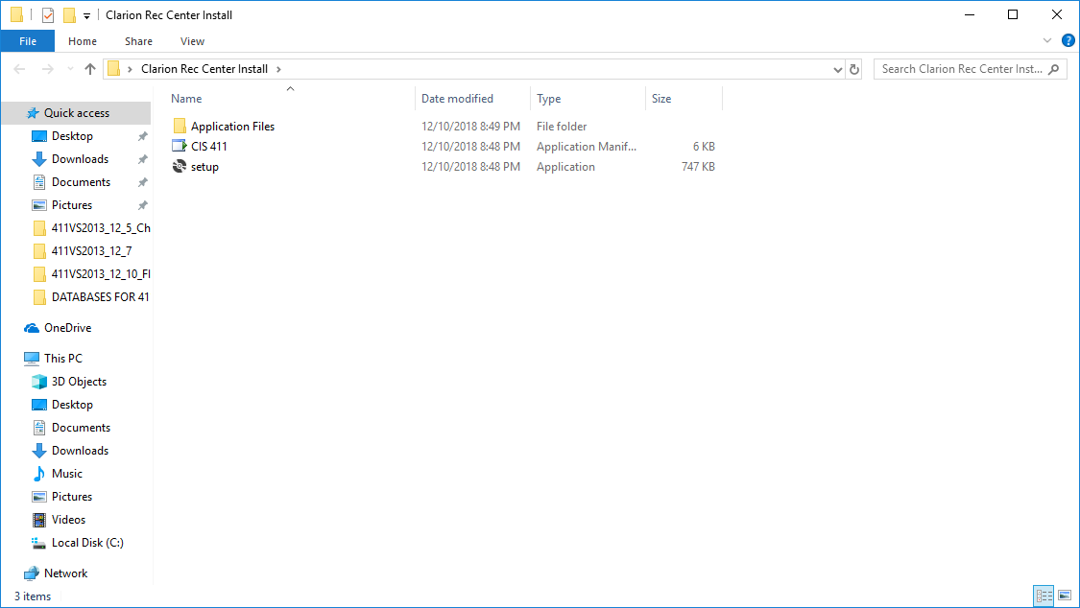

-The program will install with all prerequisites with the proper authority from computing services.

- Run the program from the shared folder.

- Use the username “admin” and password “1234” on initial program boot. All other accounts may be added as needed.

- To run the program again, open the install folder and select “Clarion Rec Center Program”.